|  |  |  |
| --- | --- | --- |
| **Mata Kuliah** | **:** | **Anatomi** |
| **Materi** | **:** | **Anatomi Digesti** |
| **NIM/Nama Mahasiswa** | **:** | ANIDA PERMATA SARI_2110101040 |

|  |  |  |  |
| --- | --- | --- | --- |
| **No** | **Keterangan** |  | **Pembahasan** |
| 1 |  | | |
|  |  | | |

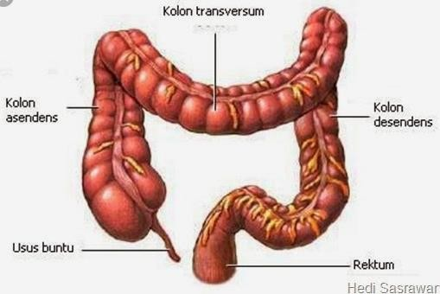

**Pembahasan**

**Keterangan**

**No**

1. Salivary glands
2. Parotid
3. Sublingual
4. Submandibular
5. Oral cavity
6. Uvula
7. Tongue
8. Esophagus
9. Pancreas
10. Stomach
11. Pancreatic duct
12. Liver
13. Gallbladder
14. Duodenum
15. Common bile duct
16. Colon
17. Transverse colon
18. Ascending colon
19. Descending colon
20. ileum
21. Cecum
22. Appendiks
23. Rectum
24. Anus
25. Esofagus
26. Kardia
27. Fundus
28. Selaput lender
29. Otot lapisan
30. Lambung mukosa
31. Tubuh perut
32. Pilorik antrum
33. Pilorus
34. Usus dua belas jari