WORKSHEETS (LEMBAR KERJA)

**Pembahasan**

**Keterangan**

**No**

|  |  |  |
| --- | --- | --- |
| **Mata Kuliah** | **:** | **Anatomi** |
| **Materi** | **:** | **Anatomi Panca Indra** |
| **NIM/Nama Mahasiswa** | **:** | Bisayarotul Walidah /2110101031 |

Lipelan antiheliks

Iris

lensa

Pupils

retina

Saraf

kornea

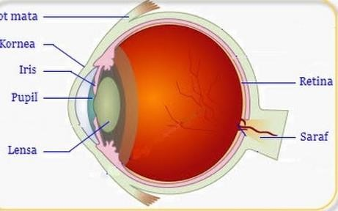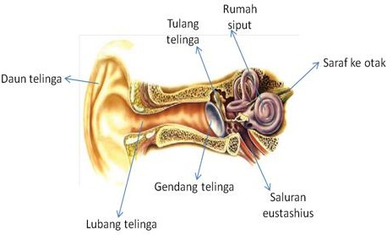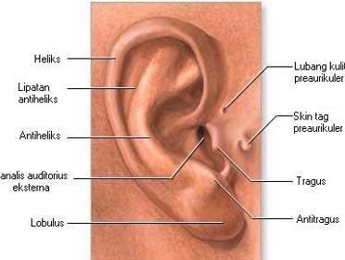

Kornea

helixs

lipelan

antiheliksss

lobulus

Antitragustitragys

Tragus

1 Mata

Telinga

Otot mata

3 saluran pertengahan lingkaran

Tulang martil

Daun telinga

Saluran eustacius

Saraf pendengaran

Gendang telinga

Saluran telinga

Antitragus

Skin tag preaurikuler

Lubang kulit preaurikuler

Kanalis auditorius eksterna

Horizontal semicular canal

Posterior Samicular canals

Superior Samicular canals

Tympanic cavity

Cochelar nerve

Vestibular nerve

Filiform papillae

Foliate papillae

Lingual tonsil

Palatine tonsil

Circulumvallate papillae

Fungiform papillae

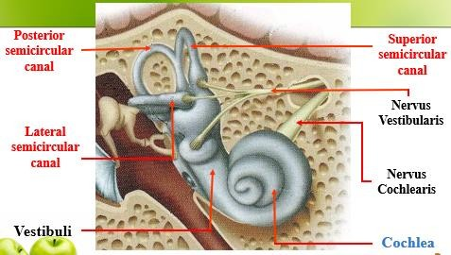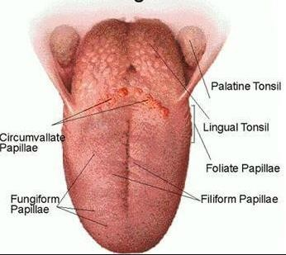

Posterior Samicular canals



Tympanic

ca

Samicular

Canals

Cochela

**Pembahasan**

**Keterangan**

**No**