WORKSHEETS (LEMBAR KERJA)

**Pembahasan**

**Keterangan**

**No**

|  |  |  |
| --- | --- | --- |
| **Mata Kuliah** | **:** | **Anatomi** |
| **Materi** | **:** | **Anatomi Panca Indra** |
| **NIM/Nama Mahasiswa** | **:** | **2110101084/Laila Oktaviyana** |

**Lubang kulit preaurikuler**

**Skin tag preaurikuler**

**Antitragus**

**Kanalis auditorius eksterna**

**Tragus**

**Lobulus auriculae**

**Helix**

**Anthelix**

**Scapha**

**Saluran eustasia**

**Saluran suara luar**

**Gendang telinga**

**Saraf rumah siput**

**Rumah siput**

**Auditory ossicies**

**Daun telinga(scapha)**

**Saraf optik**

**Retina**

**Lensa**

**iris**

**kornea**

**Otot**

**pupil**

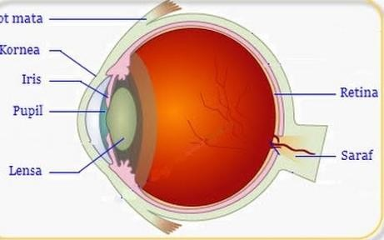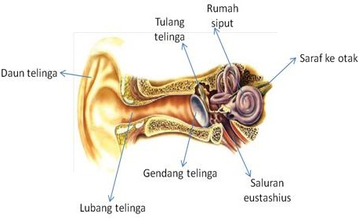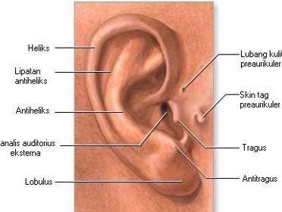

1 Mata

Telinga

**Semicircules cluct within anteriors semicor canal**

**Nervus vestibularis**

**Filiform papillae**

**Fungiform papillae**

**Circumvallate papillae**

**Foliate papillae**

**Lingual tonsil**

**Palatine tonsil**

**Semicircular Canals**

**vestibularis**

**Vestsbulcus complax**

**Rumah Siput**

**Nervus koklearis**

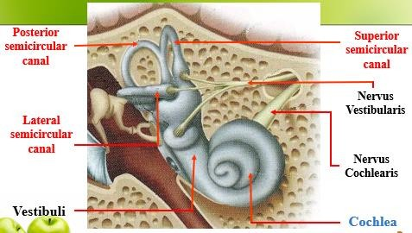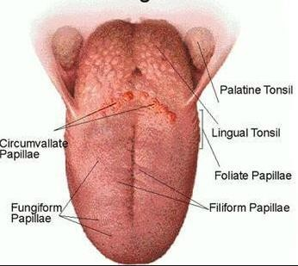

**Pembahasan**

**Keterangan**

**No**