Nama : Ira Prastika Sari
NIM : 1710301162
Kelas : 8C fisioterapi

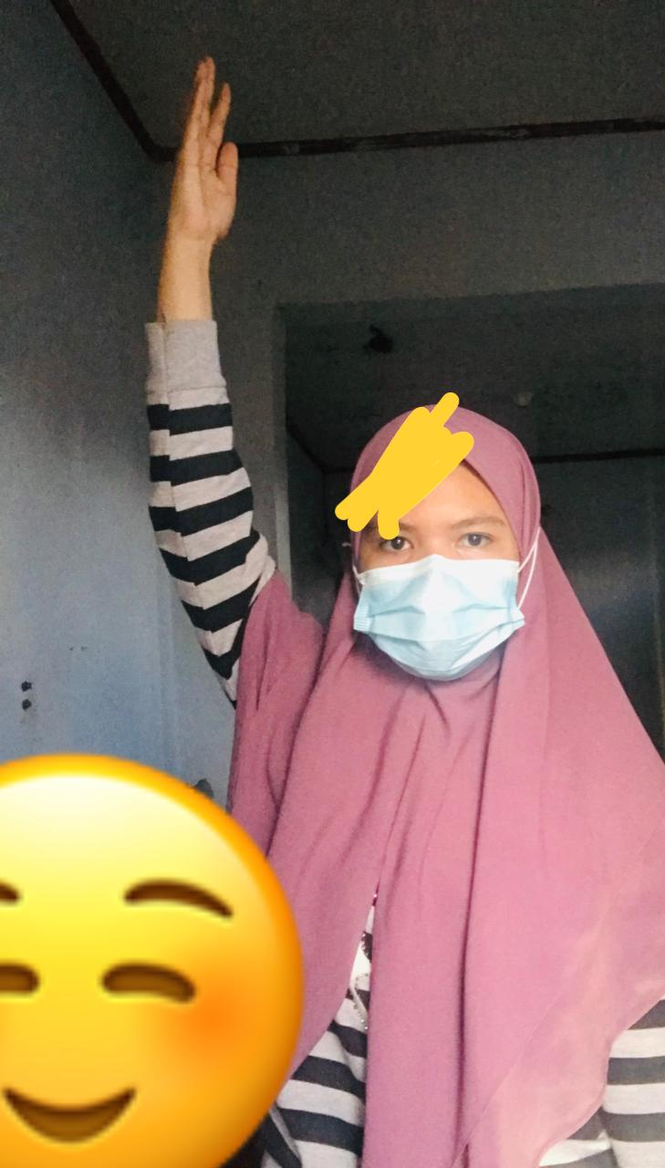

D1 Flexion
Shoulder flexi, adduksi, External rotasi
Elbow : Supinasi
Wrist : radial flexion
Fingers : flexion

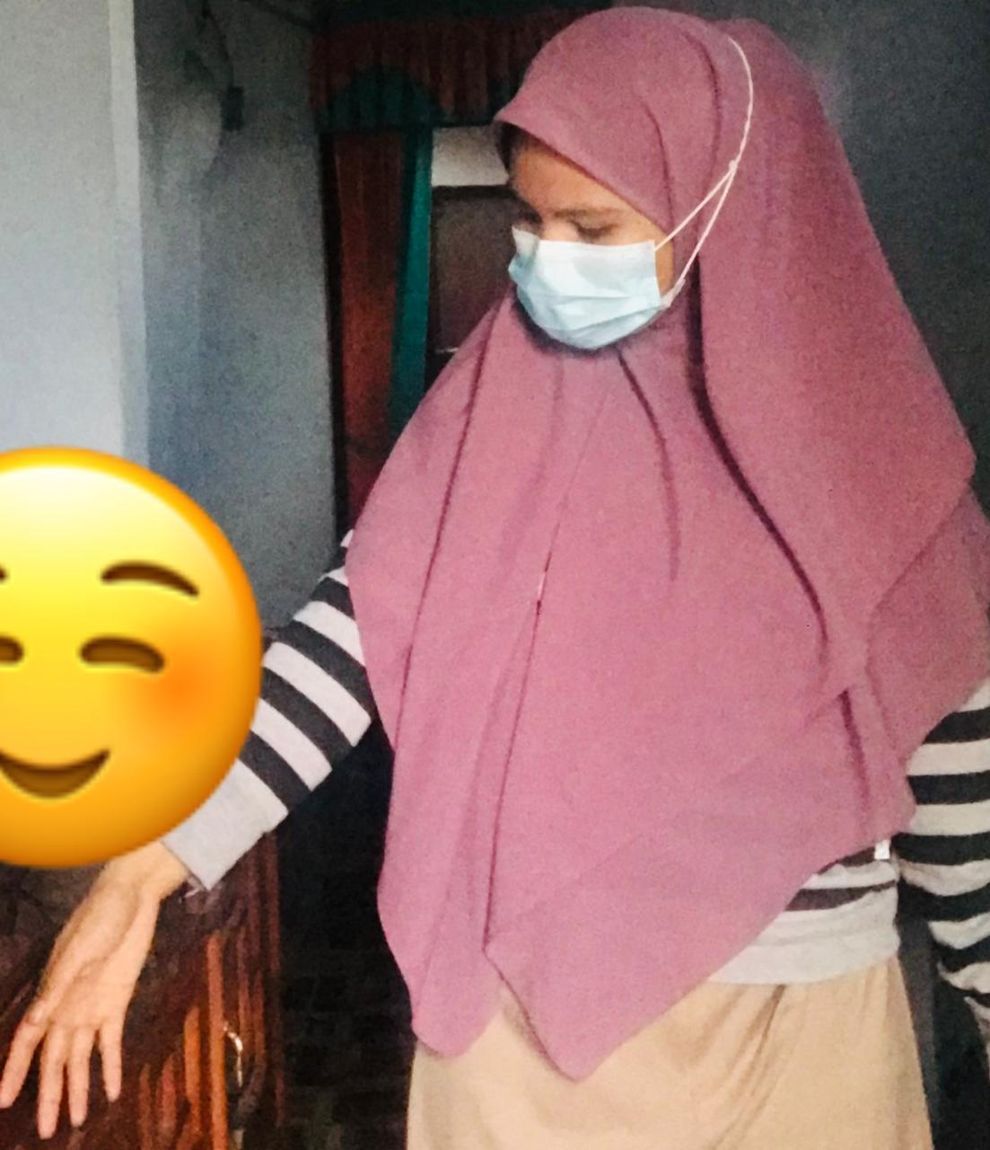

D1 Extension
Shoulder Extension, abduksi, internal rotasi
Elbow : Pronasi
Wrist : ulnar extension
Fingers : Extension

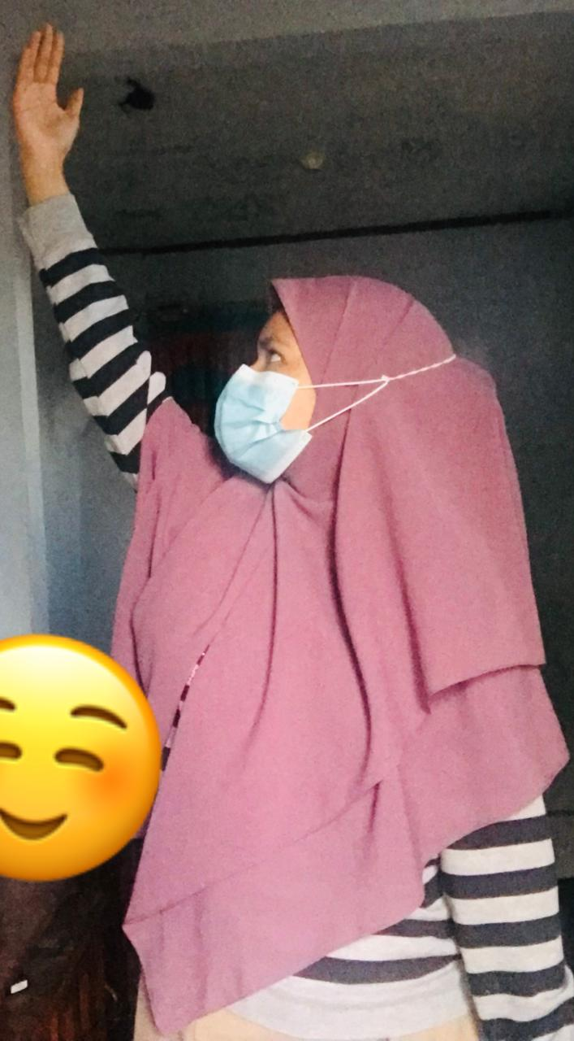

D2 Flexion
Shoulder flexion, abduksi, External rotasi
Elbow : supinasi
Wrist : Radial flexion
Fingers : flexion

D2 Extension
Shoulder Extension, adduksi, internal rotasi
Elbow : pronasi
Wrist : ulnar extension
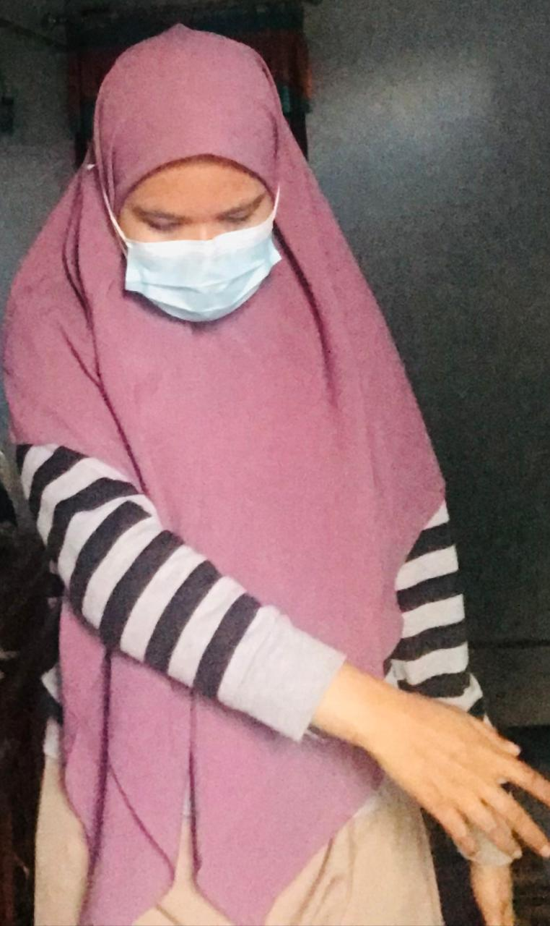
Fingers : Flexion

