Nama : Zakiyuddin Fathoni
NIM : 1710301073
Teori Tugas PNF

- D1 Flekxi
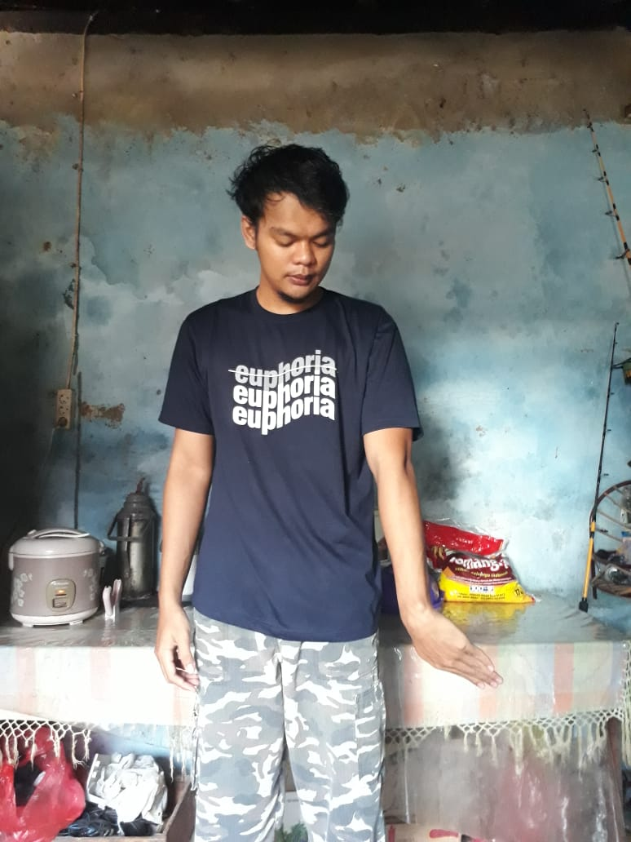
Shoulder flexion, adduction, external rotation
Forearm : Supination
Wrist : Radial flexion
Fingers : flexion

- D1 Ekstensi
Shoulder Extension, abduction, internal rotation
Forearm : Pronation
Wrist : Ulnar extension
Fingers : Extension

- D1 Fleksi
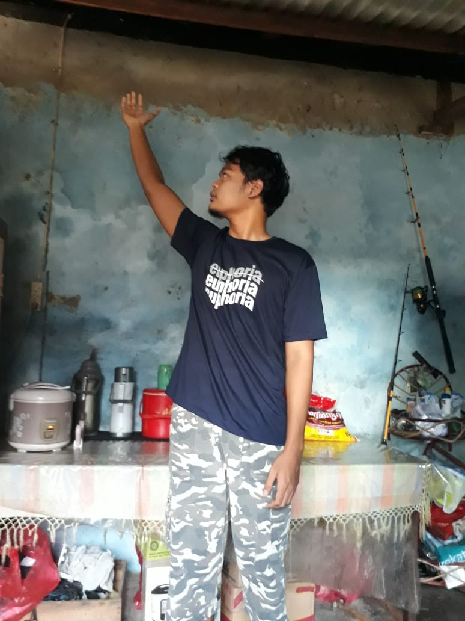
Shoulder Extention, adduction, internal rotation
Forearm : Pronation
Wrist : Ulnar extention.
Fingers : flexion

- D2 Ekstensi
Shoulder Flexion, Abduction, External rotation
Forearm : Supination
Wrist : Radial Flexion
Fingers : Extension

