Nama : Ristimah Dwi setiani
Nim : 1710301101
Kelas : 8b fisioterapi

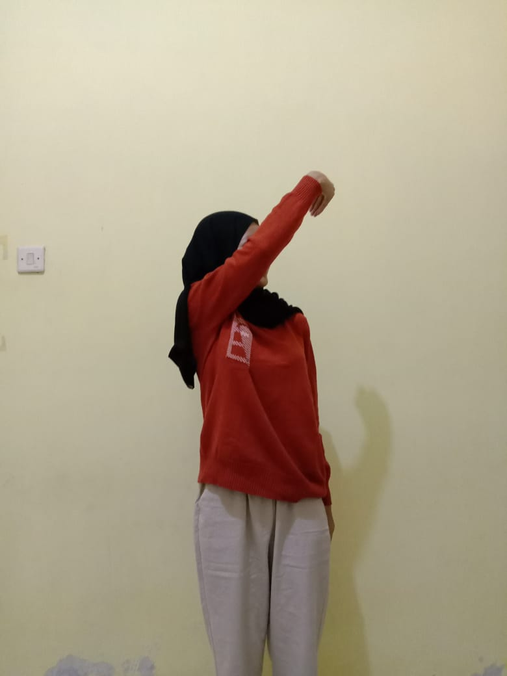
D1 Flexion
- Shoulder
Flexion, Adduction , Eksternal Rotation
- Forearm
- Supination
- Wrist – Radial Flexion
- Fingers – Flexion
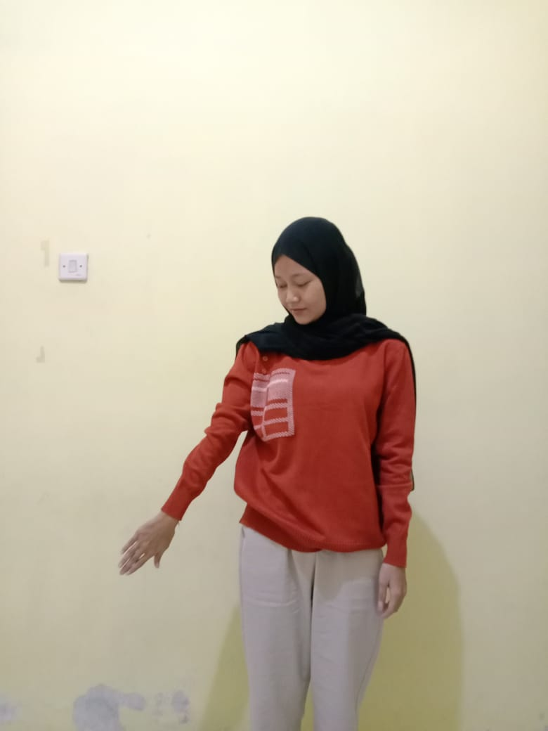
D1 Extension

- Shoulder extension , Abduction , Internal Rotation
- Forearm, Pronation
- Wrist , Ulnar extension
- Fingers , extension

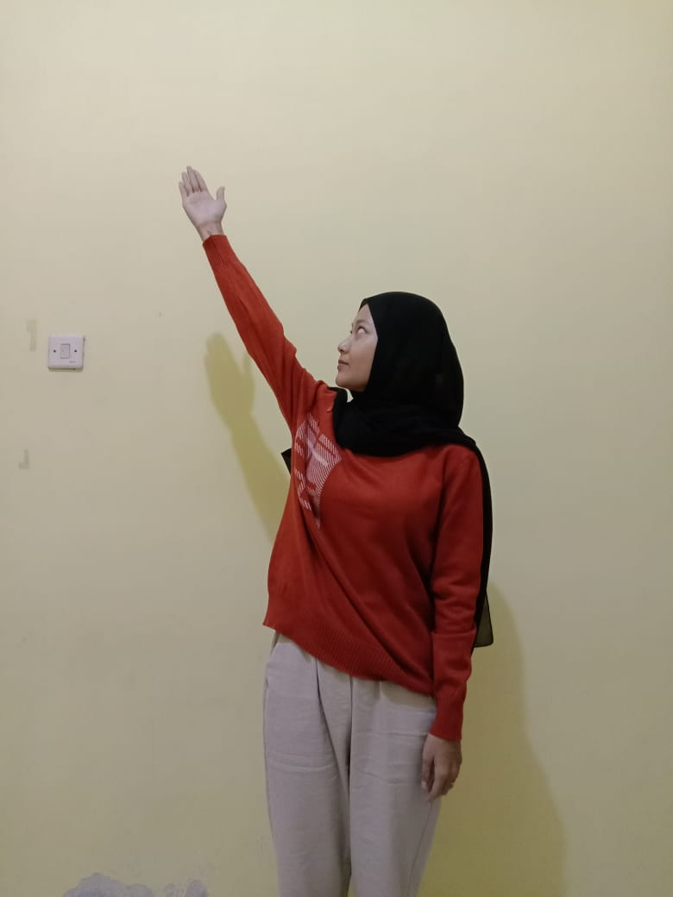
D2 Flexion
- Shoulder Flexion , Abduction Ekternal Rotation
- Forearm , Supination
- Wrist , Radial Flexion
- Finger , Extension
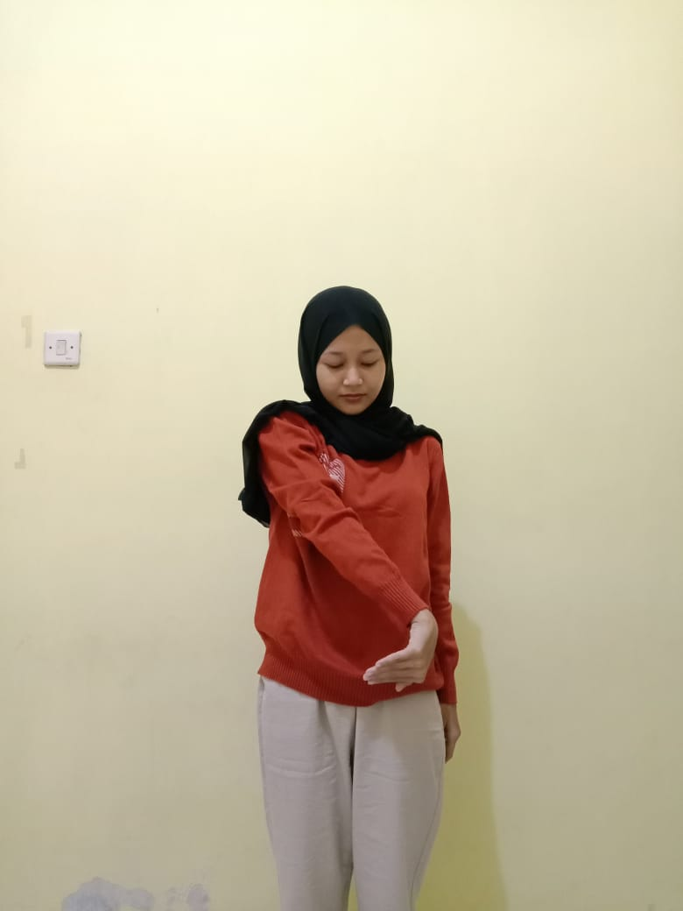
D2 Ekstension
- Shoulder Ektension , Adduction Internal rotation
- Forearm , Pronation
- Wrist , Ulnar ektension
- Fingers , Flexion

