Nama : Diffa Hannda Salsabila
Nim : 1710301022
D1 Flexion  Shoulder : flexi, add, ext rotasi  Forearm : supinasi  Wrist : radial feksi | 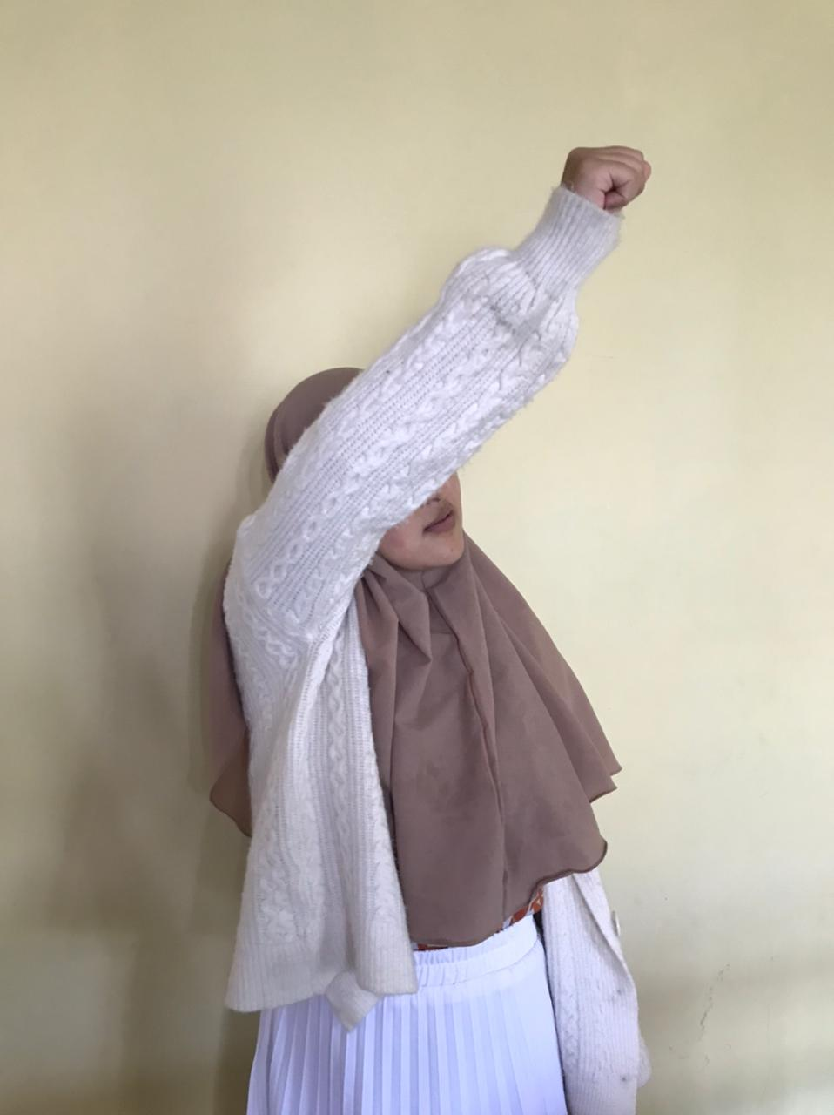
D2 extension  Shoulder : ext, abd internal rotasi  Forearm : pronasi  Wrist : ulnar, ekstensi  Finger : extensi | 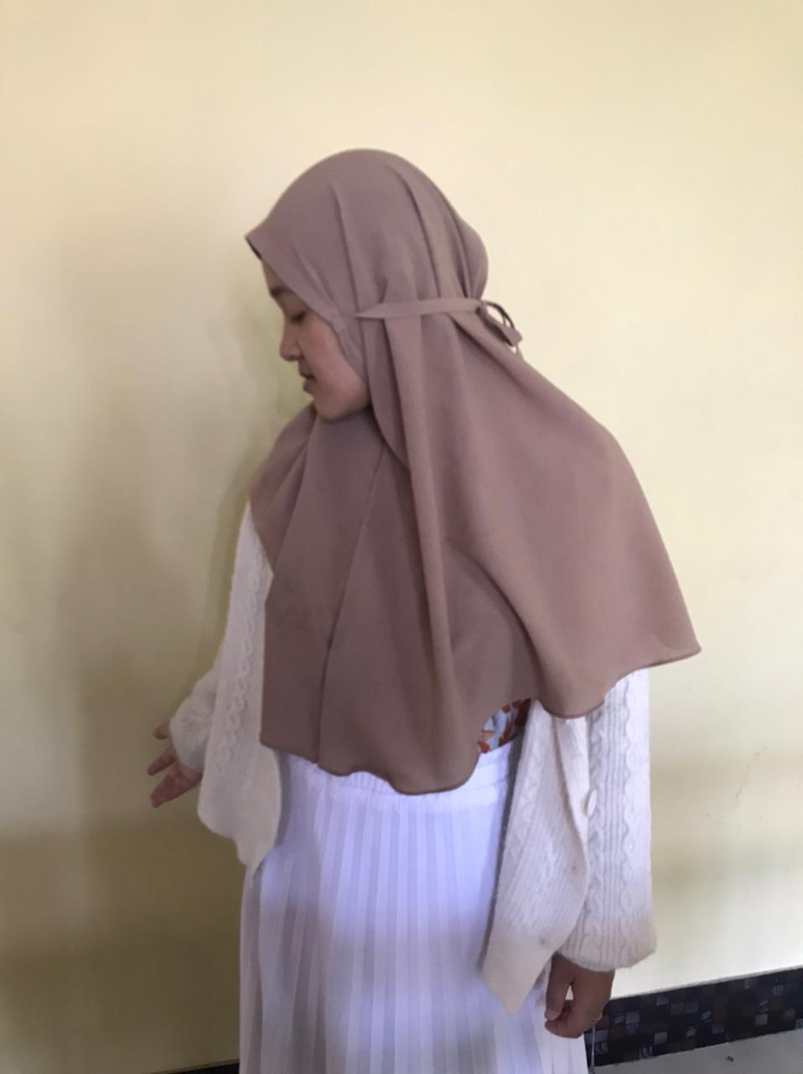
D2 Flexion
Shoulder : flexi, abd, inten rotasi
Forarm: supinasi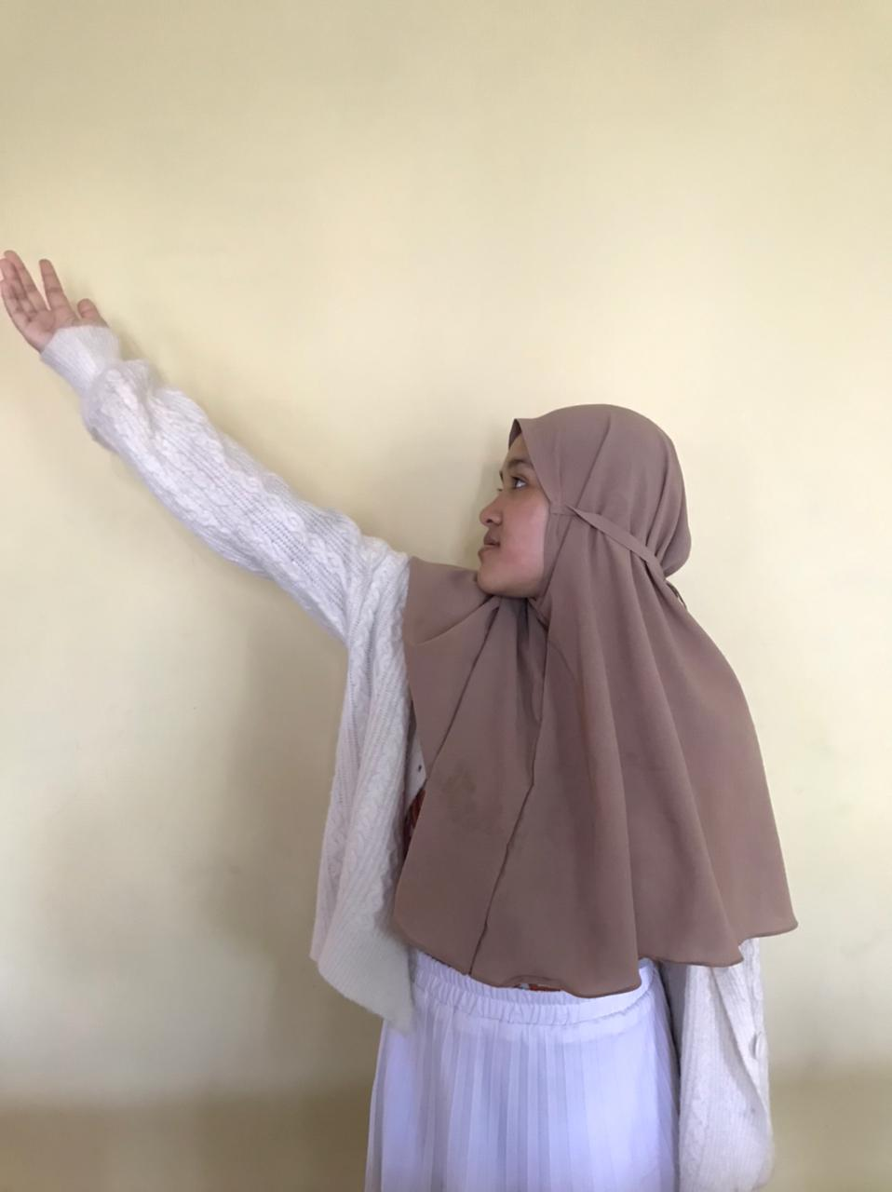
Wrist: radial fleksi
Finger : extensi
D2 ekstensi
Shoulder : ext, add, intern rotasi
Forearm: pronasi
Wrist : ulnar, extensi
Finger : flexi

