Nama : Adinda Riyan Puspita
NIM : 1710301040
Kelas : 8A

- D1 Flexion :
  - Shoulder FLEX, ADD, ER
  - Forearm – sup
  - Wrist – Rad. Flexion
  - Fingers – flexion
- D2 Extension :
  - Shoulder EXT, ADD, IR
  - Forearm – Pro
  - Wrist – Ulnar ext.
  - Fingers – flexion
- D2 Flexion :
  - Shoulder FLEX, ABD, ER
  - Forearm – Sup
  - Wrist – Rad. Flexion
  - Fingers – Extension
- D1 Extension :
  - Shoulder EXT, ABD, IR
  - Forearm – Pro
  - Wrist – Ulnar. Extension
  - Fingers – Extension

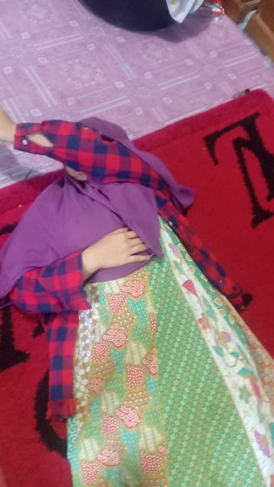
Diagonal one :
- F-ADD-ER
- E-ABD-IR
Diagonal two :
- F-ABD-ER
- E-ADD-IR

